**Assignment 4**

**AIM :**

Find a procedure to transfer the files from one virtual machine to another virtual machine.

**Theory :**

• Virtualization is the creation of virtual servers, infrastructures, devices and computing resources.

• Operating-system-level virtualization - is a server-virtualization method where the kernel of an Operating system allows for multiple isolated user- space instances, instead of just one. Such instances may look and feel like a real server from the point of view of its owners and users

• Platform / Hardware virtualization -Hardware virtualization or platform virtualization refers to the creation of a virtual machine that acts like a real computer with an operating system. Software executed on these virtual machines is separated from the underlying hardware resources. For example, a computer that is running Microsoft Windows may host a virtual machine that looks like a computer with the Ubuntu Linux operating system; Ubuntu- based software can be run on the virtual machine.

• In hardware virtualization, the host machine is the actual machine on which the virtualization takes place, and the guest machine is the virtual machine. The words host and guest are used to distinguish the software that runs on the physical machine from the software that runs on the virtual machine.

**Different types of hardware virtualization include:**

• Virtualization changes the hardware-software relations and is one of the foundational elements of cloud computing technology that helps utilize the capabilities of cloud computing to the full.

• Virtualization techniques allow companies to turn virtually their networks, storage, servers, data, desktops and applications.

**Hypervisor or Virtual Machine Monitor (VMM)**

A hypervisor or virtual machine monitor (VMM) is a piece of computer software, firmware or hardware that creates and runs virtual machines. A computer on which a hypervisor is running one or more virtual machines is defined as a host machine. Each virtual machine is called a guest machine. The hypervisor presents the guest operating systems with a virtual operating platform and manages the execution of the guest operating systems. Multiple instances of a variety of operating systems may share the virtualized hardware resources.

**Types of Virtualization**

1.Operating-system-level virtualization - is a server-virtualization method where the kernel of an operating system allows for multiple isolated user- space instances, instead of just one. Such instances (sometimes called containers, software containers,[1] virtualization engines (VE), virtual private servers (VPS), or jails) may look and feel like a real server from the point of view of its owners and users

2. Platform / Hardware virtualization -Hardware virtualization or platform virtualization refers to the creation of a virtual machine that acts like a real computer with an operating system. Software executed on these virtual machines is separated from the underlying hardware resources. For example, a computer that is running Microsoft Windows may host a virtual machine that looks like a computer with the Ubuntu Linux operating system; Ubuntu- based software can be run on the virtual machine.

3. In hardware virtualization, the host machine is the actual machine on which the virtualization takes place, and the guest machine is the virtual machine. The words host and guest are used to distinguish the software that runs on the physical machine from the software that runs on the virtual machine.

**Oracle Virtualbox**

VirtualBox is a general-purpose full virtualized for x86 hardware, targeted at server, desktop and embedded use .Each virtual machine can execute its own operating system, including versions of Microsoft Windows, Linux, BSD, and MS-DOS. VMware Workstation is developed and sold by VMware, Inc., a division of EMC Corporation

**Ubuntu**

Ubuntu is an operating system like any other and it is free & open source. It means that we can download it freely and install on as many computers as we like.

**Installation / Download**

* Oracle's Virtual Box
* Ubuntu 64 VMDK Image
* SCP Article

Steps :

1. Download and install Oracle's Virtual Box. (Reboot needed after installation)

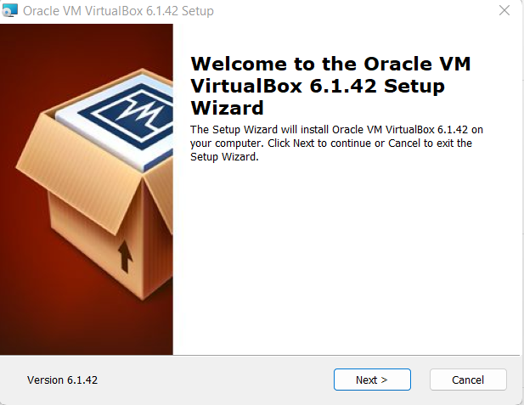

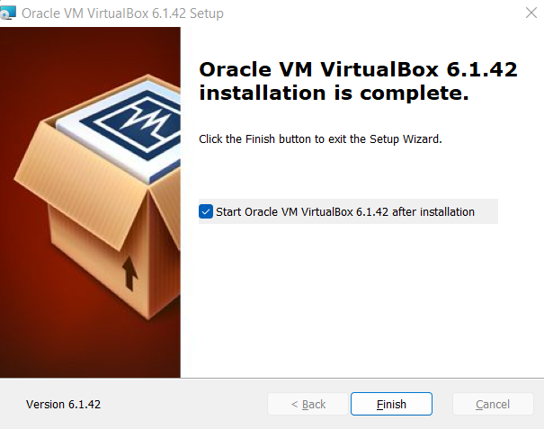

1. Download Ubuntu VMDK Image.

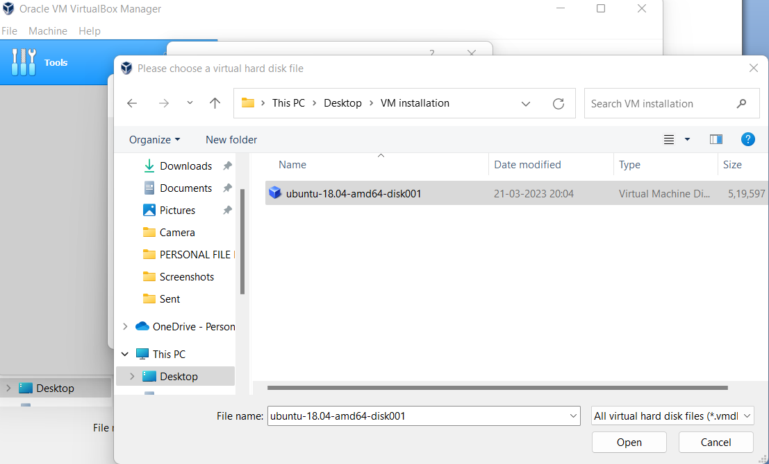

1. Launch Virtualbox and create a new VM.

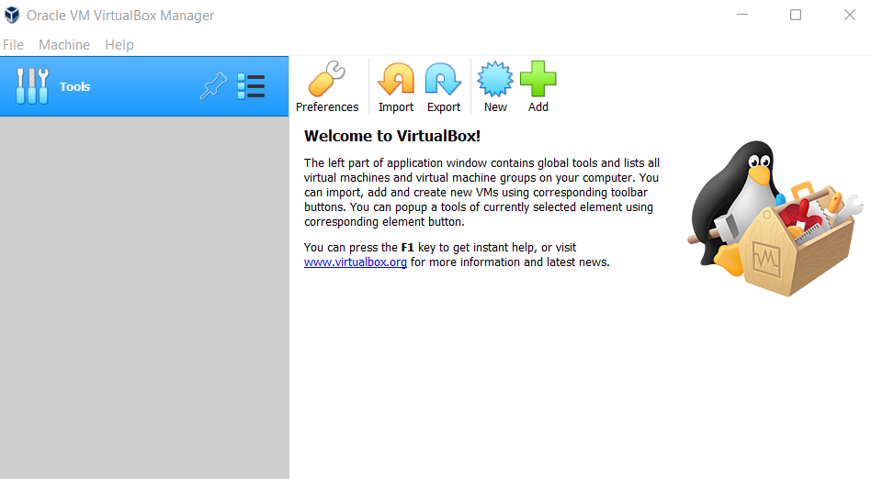

1. Click on new and mention the Name and the machine folder along with the Type and Version of the Machine to be created.

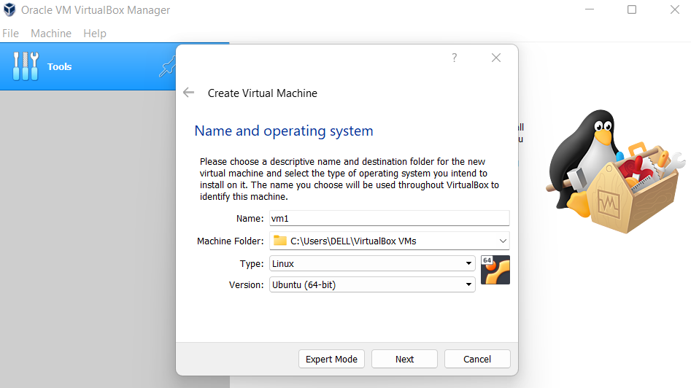

1. Assign memory size for our VM (1024 MB sufficient for now). 6. Select the option Use an existing virtual hard disk file and locate the downloaded VMDK image below and create VM.

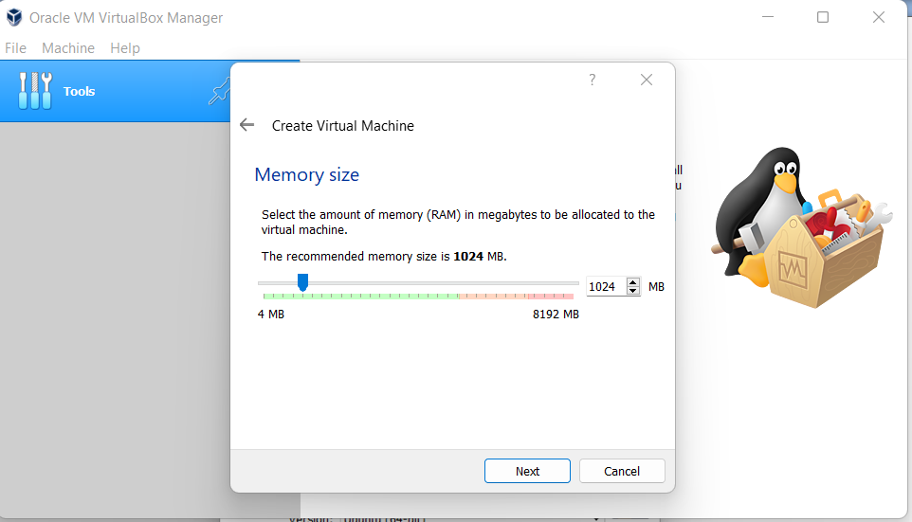

7. Now we have to create a NAT Network so go to File -> Preferences -> Network ->Add a New NAT Network (Click on +)

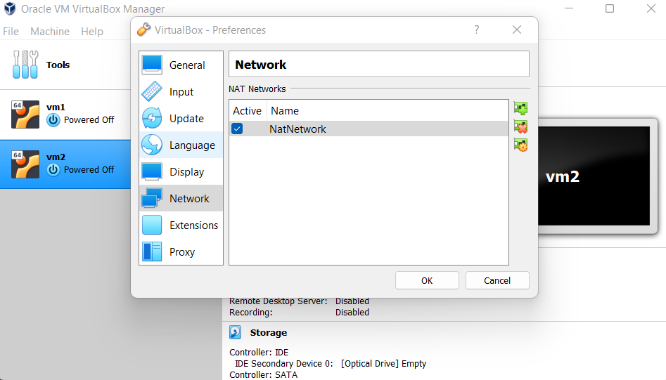

8. Right click and edit the Network name and CIDR if needed. Example: Name - My VMbox Network

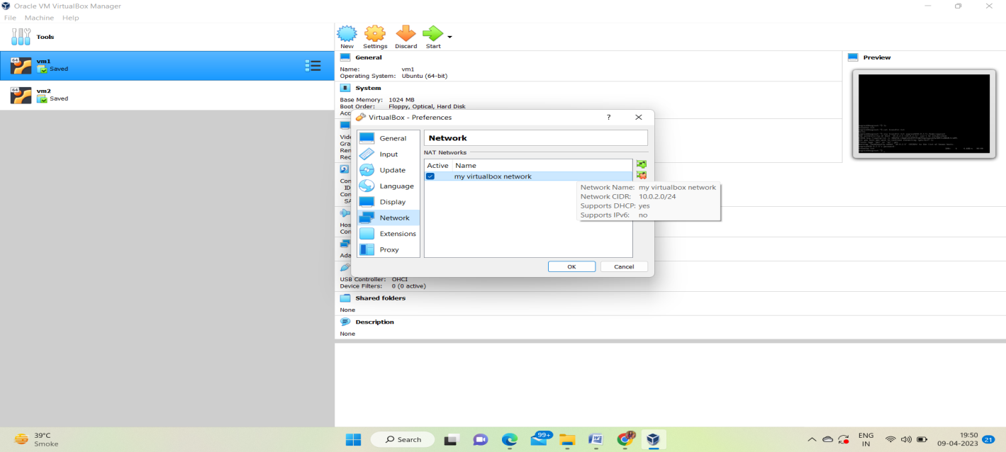

CIDR - 172.168.2.0/24 and save the changes.

1. Repeat the process of launching the VM for 2 instances.

2. Now go to the setting, go to the network setting and change the adapter to NAT Network and select the NAT Network you made ( in our case : My VMbox Network ) and click ok.

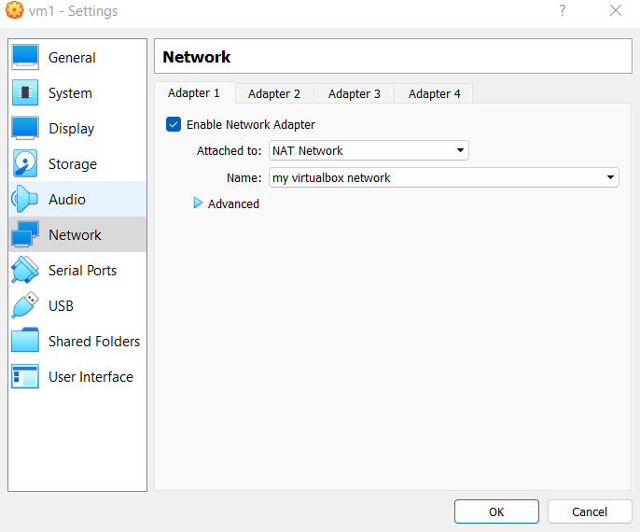

3. Launch the VM now.

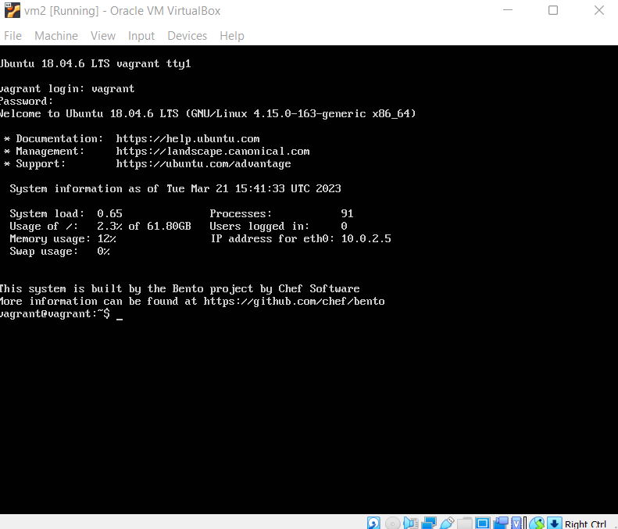

4. Install the net-tools to know the IP's of the instance

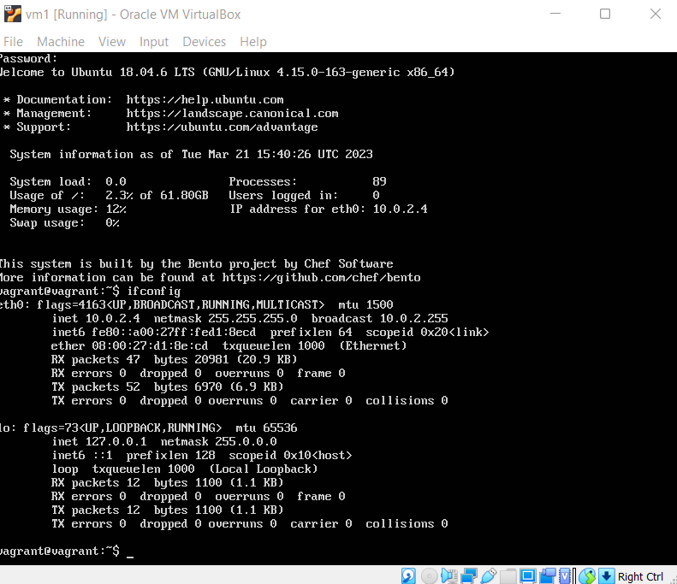

If your file is on the VM with IP 10.0.2.4 and the second VM's IP is 10.0.2.5

Transfer the file using SC Command

